INVESTMENT TEASER
Industrial & Logistics Complex | Southern Poland (Małopolska)
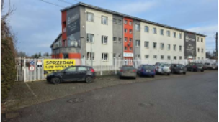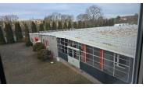
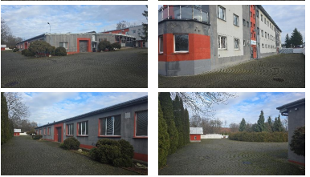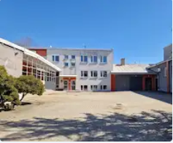
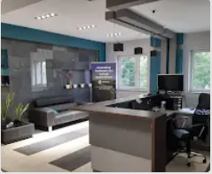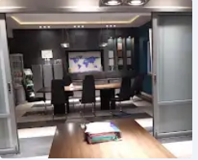

Executive Summary
A fully operational industrial and logistics complex located in Southern Poland, within an established industrial zone. The property benefits from direct access to the S7/E77 Warsaw–Kraków Expressway, one of Poland's most important transport corridors, providing outstanding connectivity for domestic and international logistics. The asset is immediately available for manufacturing, warehousing or distribution operations.

Key Facts
- Total land area: 0.8245 ha.
- Total gross usable area: approximately 3,870 sq m.
- Production halls, warehouses, offices and staff facilities.
- Fully serviced site with electricity, gas, water, sanitary and stormwater drainage.
- Truck manoeuvring areas, parking and convenient heavy vehicle access.
- Independent market valuation: PLN 5.534 million (net).

Investment Highlights
- Prime location directly on the S7/E77 Warsaw–Kraków transport corridor.
- Suitable for manufacturing, logistics, e-commerce and distribution activities.
- Operational industrial facility with developed office and warehouse infrastructure.
- Property modernised with upgraded roofing, heating systems, heat pump, LED lighting, CCTV and access control.
- Ready for immediate occupation with limited additional capital expenditure.

Potential Uses
• Manufacturing
• Logistics & Distribution Centre
• High-bay Warehousing
• E-commerce Fulfilment
• Assembly Operations
• Light Industrial Production

Disclaimer
This teaser has been prepared for information purposes only and does not constitute an offer. Further information and supporting documentation will be provided to qualified investors following the execution of a Non-Disclosure Agreement (NDA).

